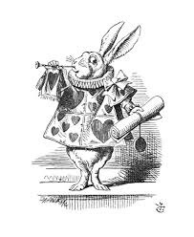
Invitation

“Why, sometimes I've believed as many as six impossible things before breakfast.”

The Queen of Hearts and the Mad Hatter Cordially Invite You To A

Welcome Event for Current and Prospective Families
Fri 28th Sept 3.30-5.15pm
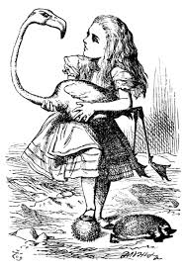
Hipsburn Primary School
Collect your child as normal, then join in the fun*

Activities to include: Tea and Unbirthday Cake Stall, Caucus Races, Follow the White Rabbit, Tweedledum Tin Can Alley, Storytelling, Dormouse Tea Pot challenge, Off with your Head Croquet and more! Golden Pinecones to be won!
All proceeds will go towards our future events’ programme.

*children are the responsibility of their carer at all times, not the school.

